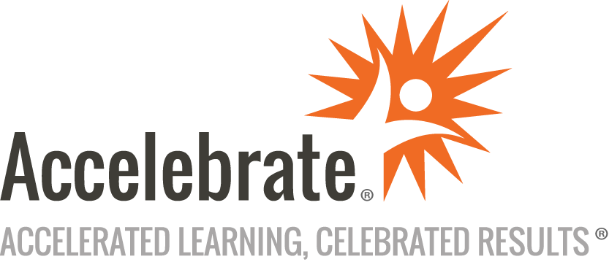

**Introduction to Spring Boot**

**Course Number:** SPRG-181  
**Duration:** 3 days

**Overview**

Spring Boot allows Java developers to create standalone Spring applications that "just run," typically using an embedded instance of Tomcat, Jetty, or Undertow.  These Spring Boot applications require no code generation or XML configuration, while at the same time they feature integrated health monitoring, simplified Maven configuration, and a host of other features that make building, deploying, and running your Spring applications far easier.

Accelebrate's Spring Boot training teaches attendees Spring from the ground up, including overviews of building blocks such as Maven. This course covers the key features and capabilities of Spring Boot and gives experienced Spring developers the skills they need to use Spring Boot productively.

**Prerequisites**

All attendees must already have a strong understanding of Spring Core and ideally Spring MVC as well.

**Materials**

All attendees receive comprehensive courseware covering all subjects in the course.

**Software Needed on Each Student PC**

* JDK 8 or later
* IntelliJ IDEA, Eclipse with Spring Tools, or another IDE of your choice
* Other free software - please contact us if you have purchased this class.

**Objectives**

All attendees will:

* Get an overview of Spring Core (focus on @Configuration) and maven/gradle - building blocks for Spring Boot
* Understand the needs that Spring Boot fulfills
* Use Spring Boot starters and start.spring.io to easily create new applications
* Understand and use Spring Boot's auto-configuration
* Customize your application configuration
* Understand and use Spring Boot's Spring Data / Spring Data JPA capabilities
* Understand and use Spring Boot's Web capabilities (focusing on Spring REST), including embedded servlet containers
* Be familiar with Spring Boot Data REST
* Use Spring Security with Spring Boot
* Understand and use Spring Boot's Actuator
* Use Actuator endpoints to monitor and manage applications
* Be familiar with and work with Spring DevTools
* Be familiar with the Spring CLI

**Outline**

* Introduction
* Spring Configuration Overview
  + Spring Review - XML and @Component
  + Dependency Injection
  + Java-based Configuration (@Configuration)
  + Integrating Configuration of Different Types
* Introduction to Spring Boot
  + Brief maven Overview
  + Intro to Spring Boot - What is Spring Boot and What It Does
  + Spring Boot Hello World / SpringApplication
  + SpringBootApplication / CommandLineRunner / ApplicationRunner
* Configuration and Customization
  + Working with Properties - YAML and .properties
  + Logging and its Configuration
  + Spring TestContext Framework
  + Auto-configuration Overview
  + Customization
* Spring Boot Database Support
  + Basic Auto-configuration - Datasource and Pooling
  + Configuration Properties
  + Spring Boot's JPA Support - spring-boot-starter-data-jpa
  + Spring Boot Data (with Data-JPA in Detail)
  + Using Spring Boot Data - CrudRepository/JpaRepository
  + Defining Queries with Spring Boot Data
* Spring Boot Web/REST and Security
  + DispatcherServlet Review
  + Web Starters and Configuration spring-boot-starter-web
  + Using Embedded Servers (Tomcat, Netty)
  + Deploying to an External Server
  + Spring Security Overview (Web)
  + spring-boot-starter-security - Auto-configuration and Customization
  + Spring Boot Data Rest - Generated Web Services from Repositories
* Actuator and Devtools:
  + Actuator Overview and Capabilities
  + Actuator Endpoints
  + Custom Actuators and Health Checks
  + Devtools Overview
  + Other Tools and Features
* Spring Boot CLI
  + Overview and Capabilities
  + Grabbing / @Grab
  + Other Capabilities
* Conclusion